The laboratory work 5

Exercise 1: Given a string of odd length greater than 7, return a new string made of the middle three characters of a given String
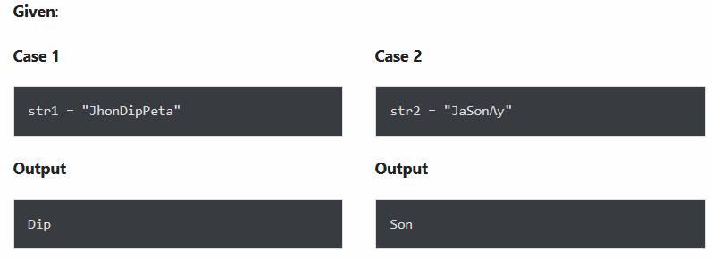

Exercise 2: Given two strings, s1 and s2, create a new string by appending s2 in the middle of s1

Exercise Question 3: Given two strings, s1, and s2 return a new string made of the first, middle, and last characters each input string

Exercise 4: Arrange string characters such that lowercase letters should come first
Given an input string with the combination of the lower and upper case arrange characters in such a way that all lowercase letters should come first.

Exercise 5: Count all lower case, upper case, digits, and special symbols from a given string
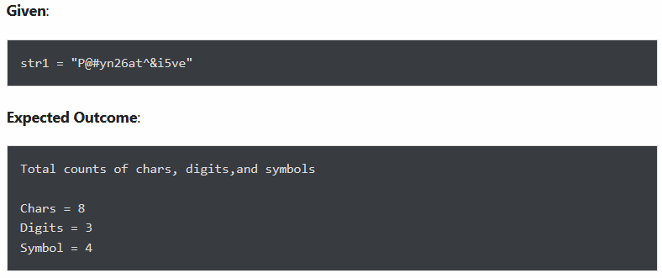

Exercise 6: Find all occurrences of “USA” in a given string ignoring the case
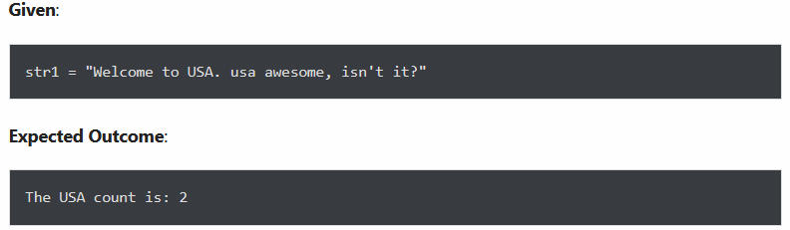

Exercise 7: Given an input string, count occurrences of all characters within a string
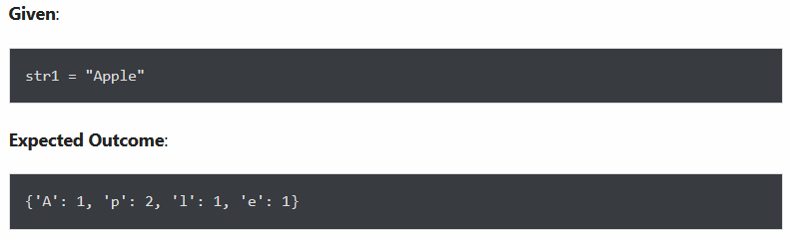

Exercise 8: Reverse a given string

Exercise 9: Find the last position of a substring “Emma” in a given string
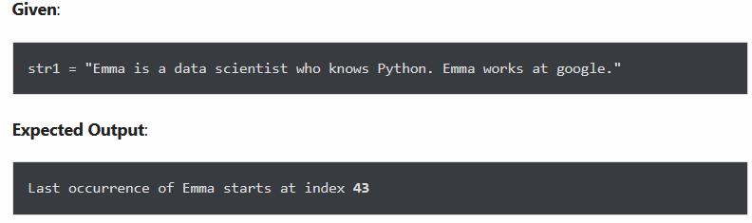

Exercise 10: Split a given string on hyphens into several substrings and display each substring
